1. Create a Kubernetes cluster in GCP/GKE and deploy a simple spring boot application.

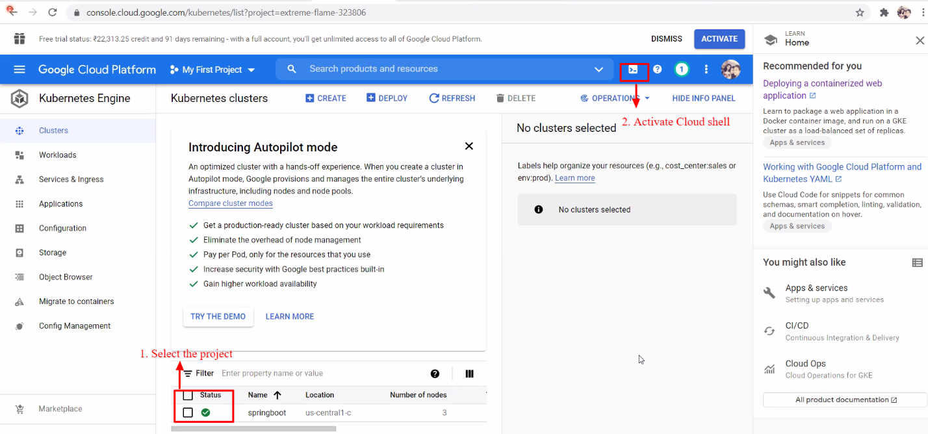

1. Now get the source code

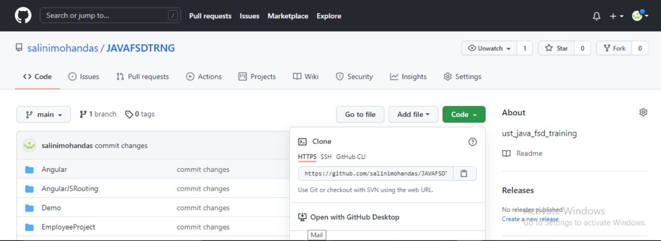

Use the command line to clone the source code in the home directory

1. Use the command line to clone the source code in the home directory.

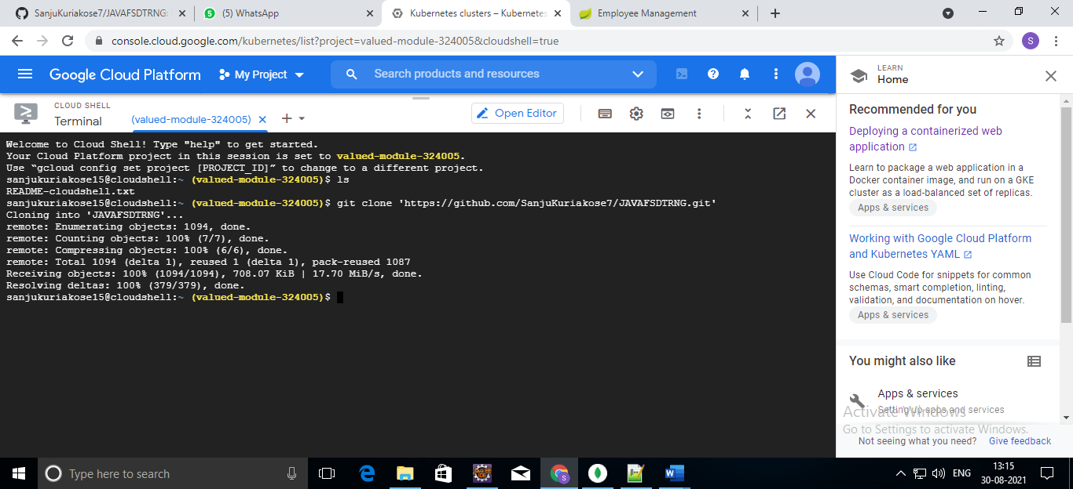

1. To change directory use cd command

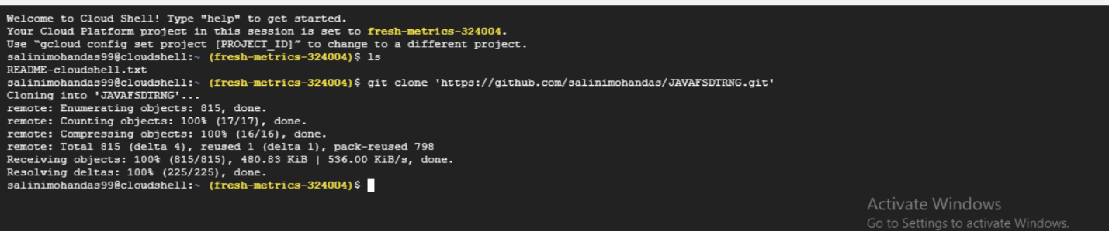

1. To install maven use ./mvnw clean install command

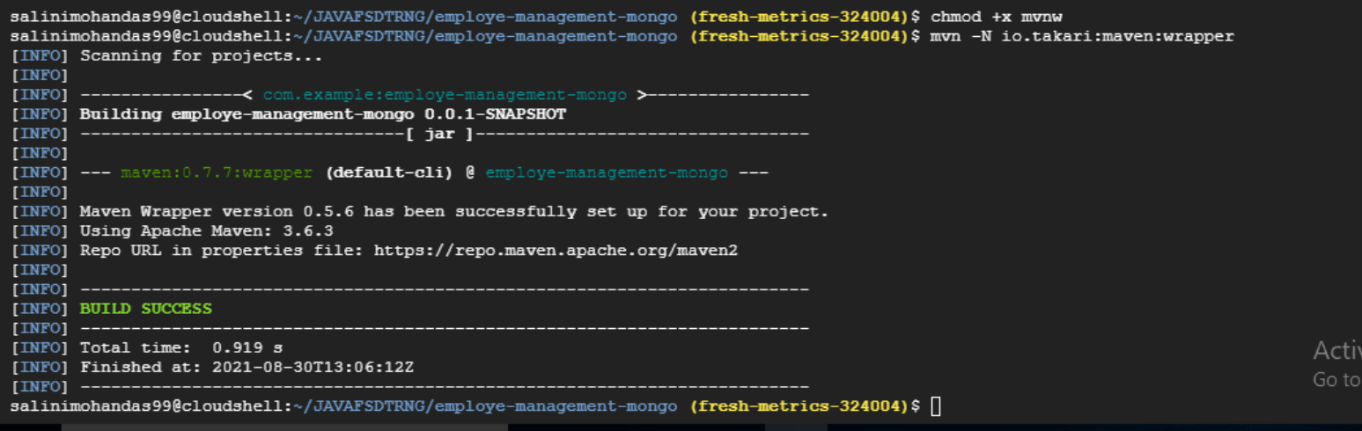

Installation…

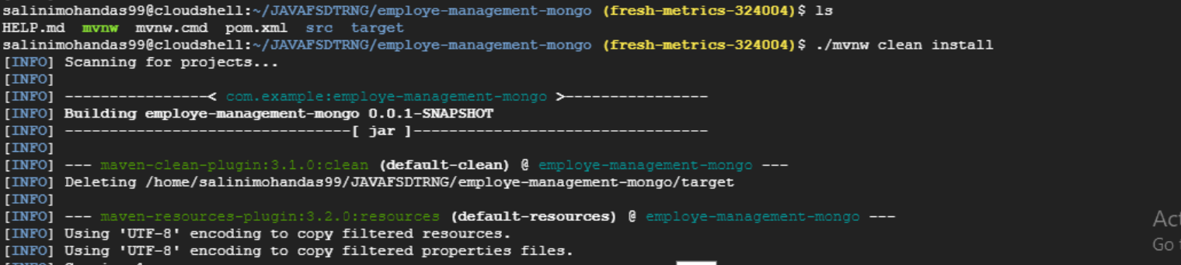

1. To run the project use java -jar

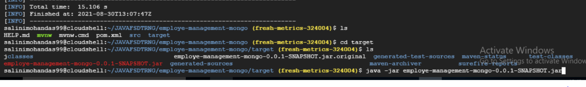

1. A tab in your browser opens and connects to the server you just started.

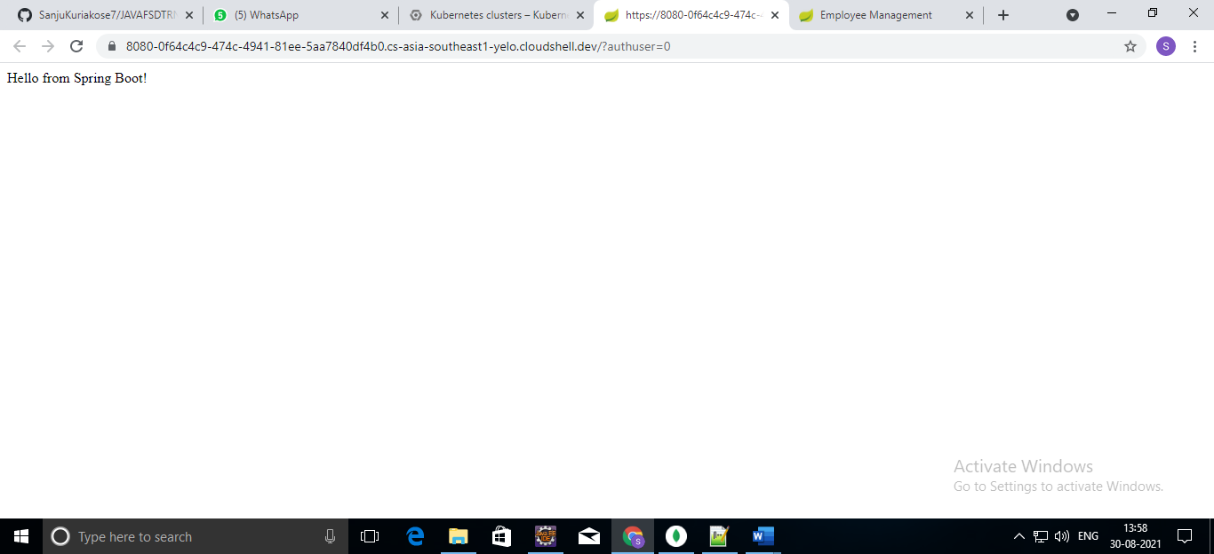

1. Deploy the parallel project (Employee Management portal) onto the GKE.

To deploy a Employee Management Project to Kubernetes on GKE.

Cloud Console URL: console.cloud.google.com

1. Now click on Kubernetes Engine >> Clusters

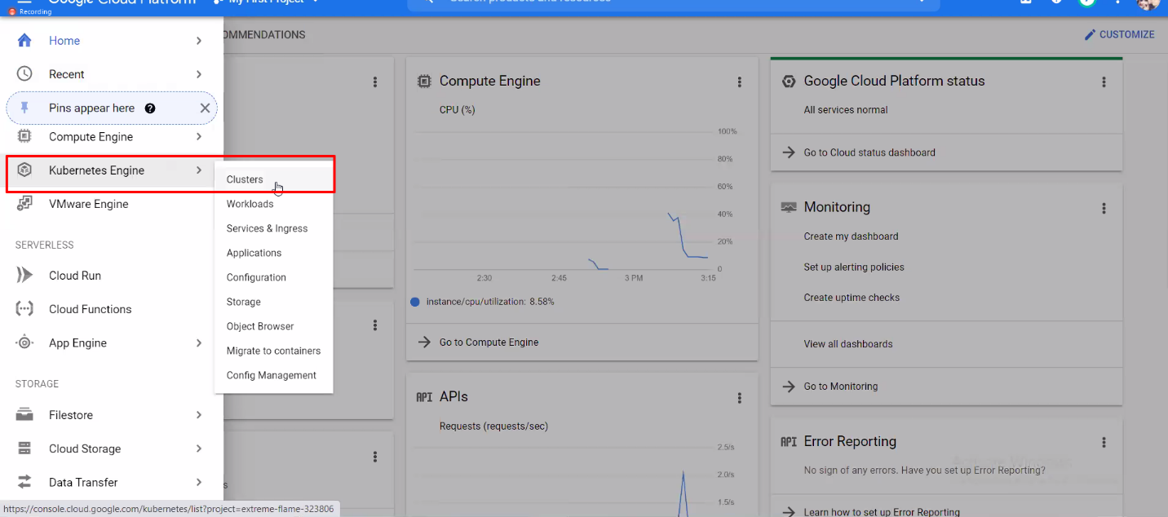

2.Now click on Configure

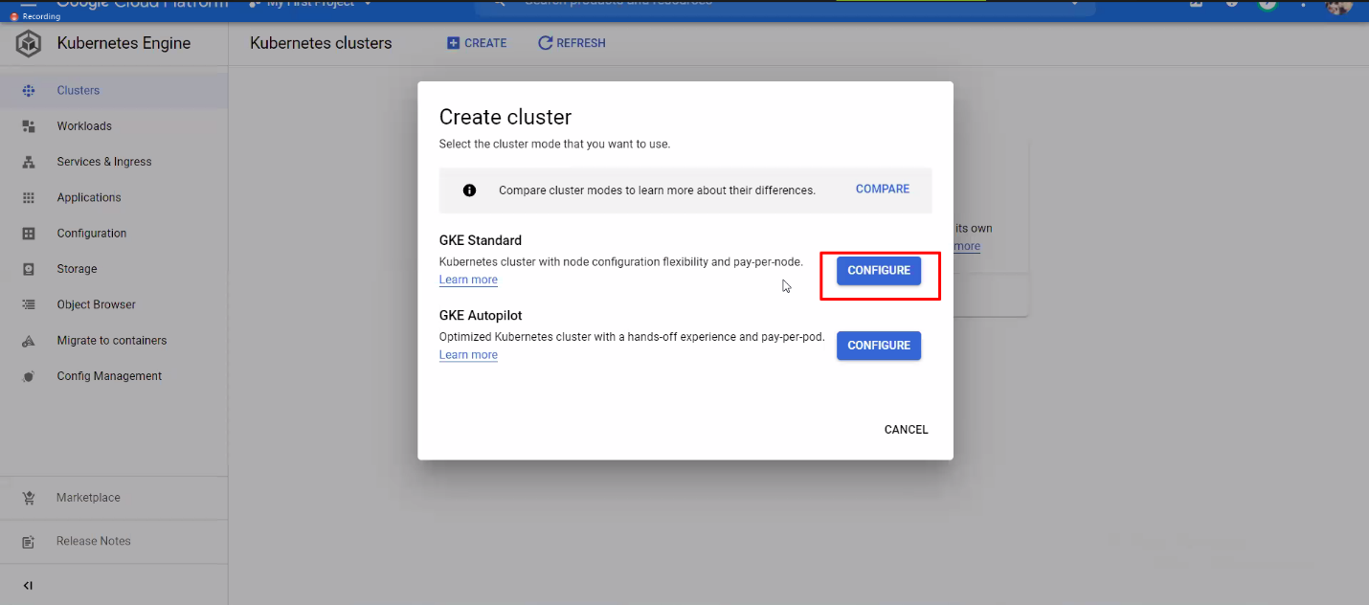

3.Enter the name of the Project and click on create.

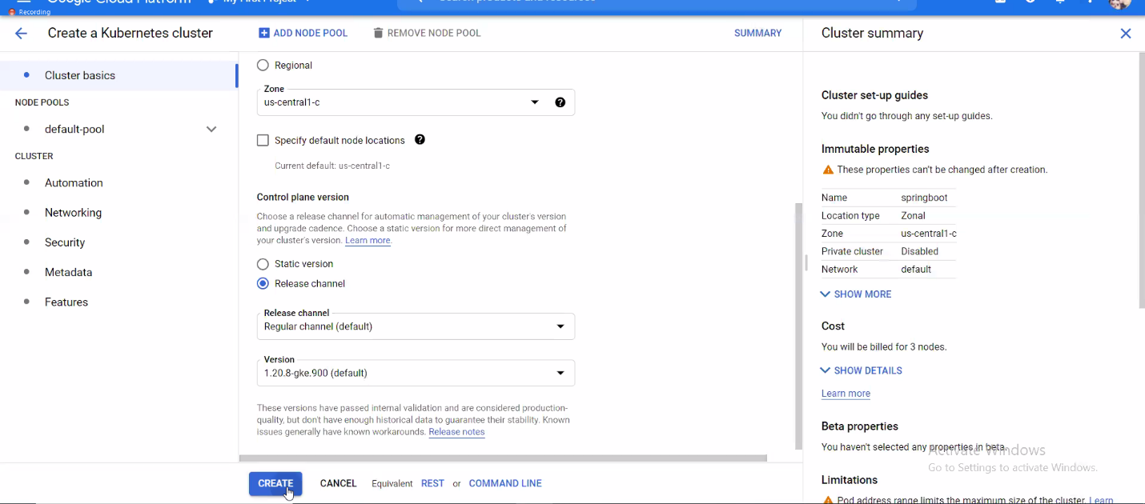

4.Select the project and goes to the Web Preview. Preview on port 8080.



5.Now get the source code



6.Use the command line to clone the source code in the home directory.



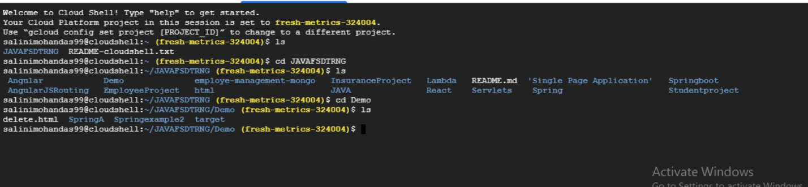

The Employee Management Project is connected with microservice. So There is 2 projec we want to run : SpringA and Springexample2.

SpringA:

7. Use the command ‘cd’ to change the directory

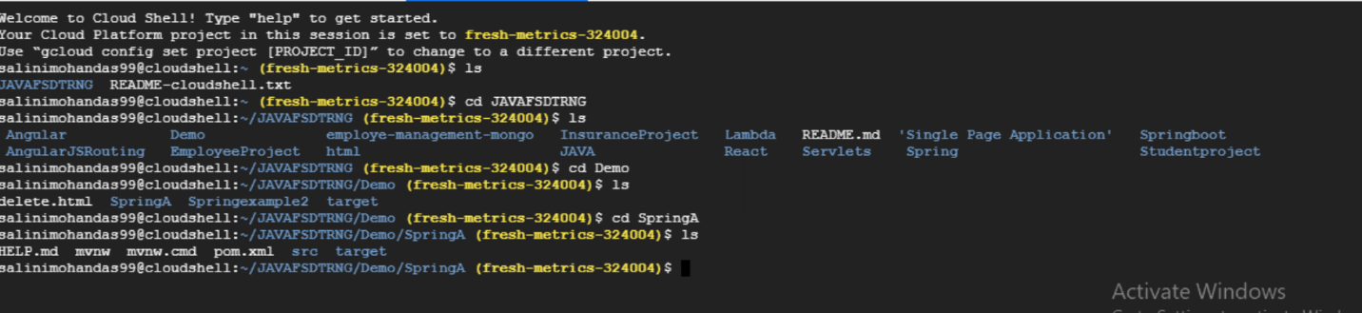

8.Use command line ./mvnw clean install to install maven.

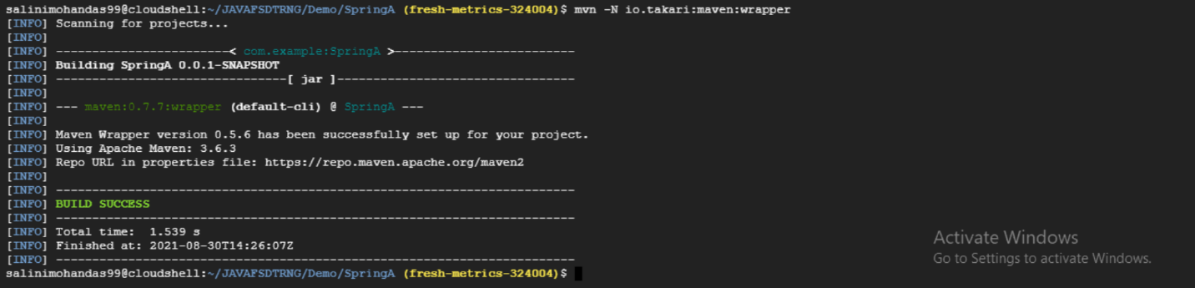

Installation…

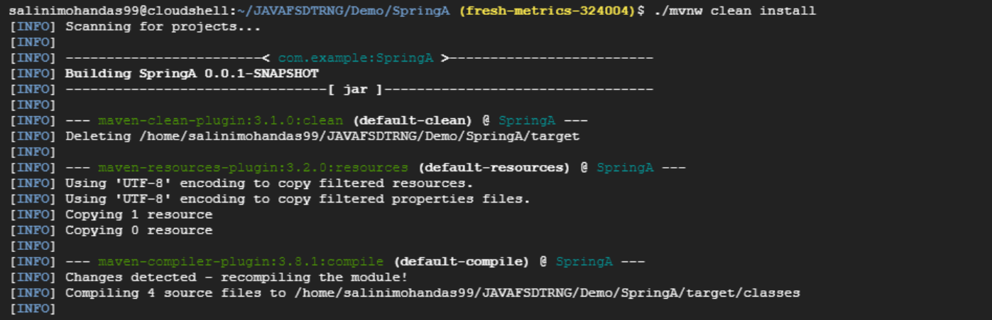

9. To run the Project use the command ‘java -jar’

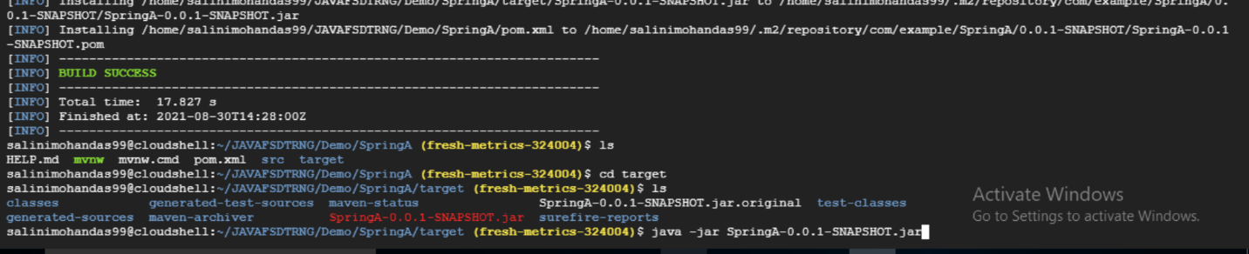

Springexample2:

Take another terminal and follow the above steps to run the Springexample2.

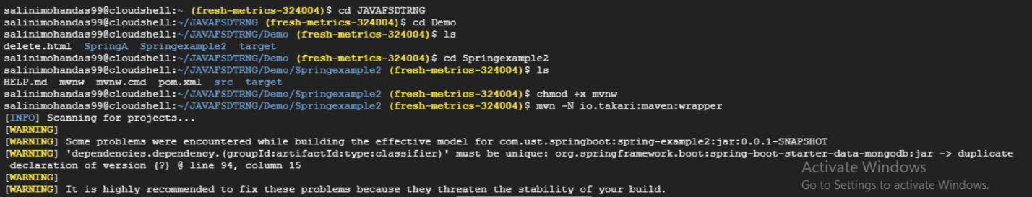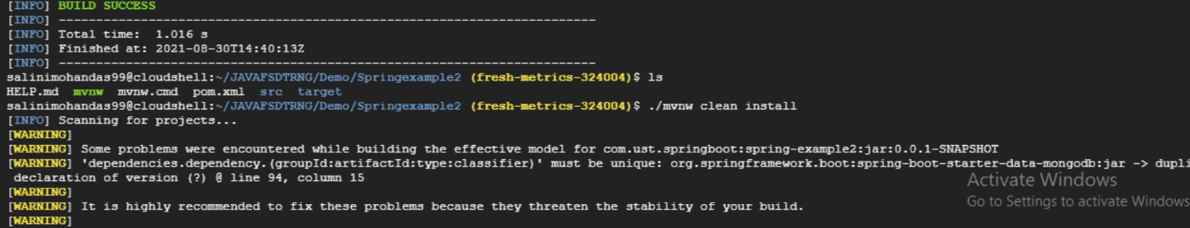

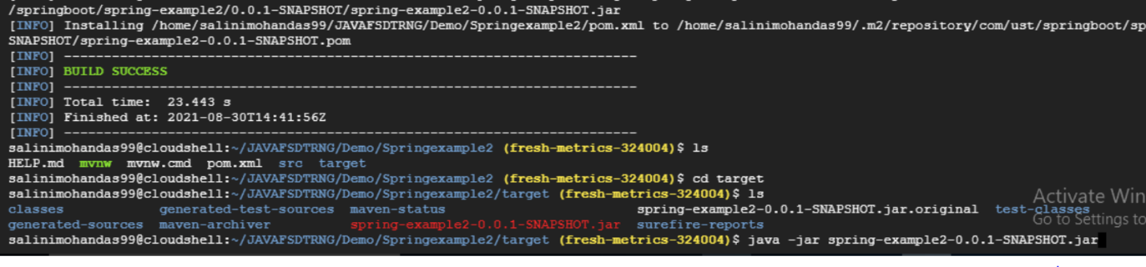

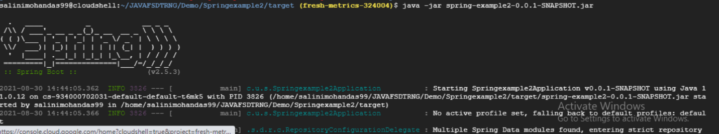

10. A tab in your browser opens and connects to the server you just started.

